**Part A: System Documentation**

**1.Requirements Elicitation**

1.1. Functional Requirements

* Customer Management-the system shall allow a new customer to register with the bank by providing personal information and also allow them to be associated with multiple accounts.
* Account Management-the system shall allow customers to open different types of accounts.
* Transaction Management-the system shall allow customers to deposit funds into any of their accounts, withdraw from investment and cheque accounts and reject withdrawals from savings account.
* Interest Calculation and Payment-the system shall calculate and credit monthly interest to Investment and Savings accounts based on their respective rates.
* Account Validations-the system shall ensure the initial deposit for Investment accounts is at least P500 and also verify employment details for customers opening cheque accounts.
* Reporting-the system shall generate account statements showing transactions, current balance, and interest earned and also provide summary reports for customers.
* Security and Data Integrity-the system shall ensure that accounts cannot exist without an associated customer.

1.2. Non-Functional Requirements

* Security- all customer’s data must be stored securely by using encrypted passwords and secure login to prevent unauthorized access.
* Performance- transactions should be processed fast and the system should support at least 100 simultaneous users without performance degradation.
* Usability-the system should provide a simple intuitive graphical user interface (GUI) that requires minimal training to operate it.
* Availability-the system should be available 24/7 with more than 99.5% uptime ensuring continuous access for users.
* Maintainability-the codebase should use modular object-oriented principles to allow for easy maintenance and future updates.

**2.Structural UML Modelling**

2.1. System Use Case Diagram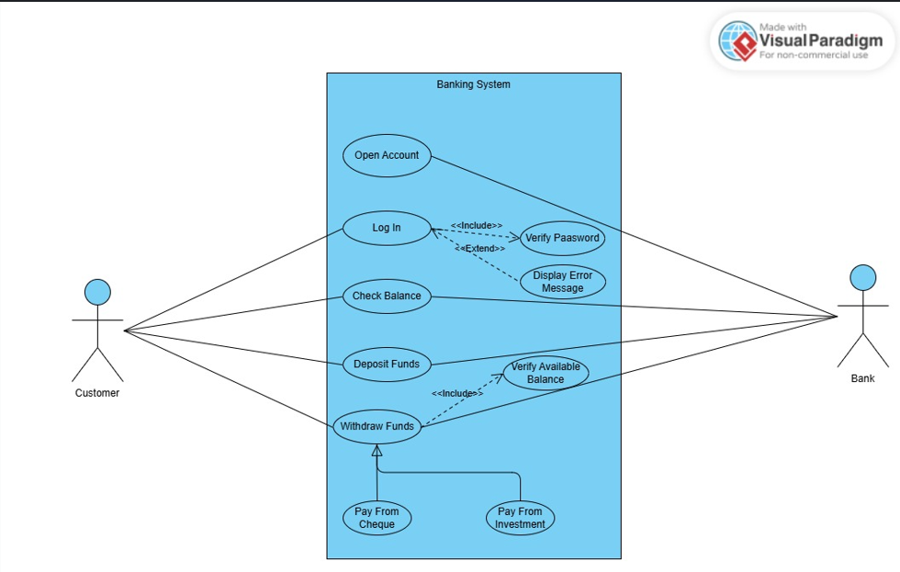

2.2. Class Diagram

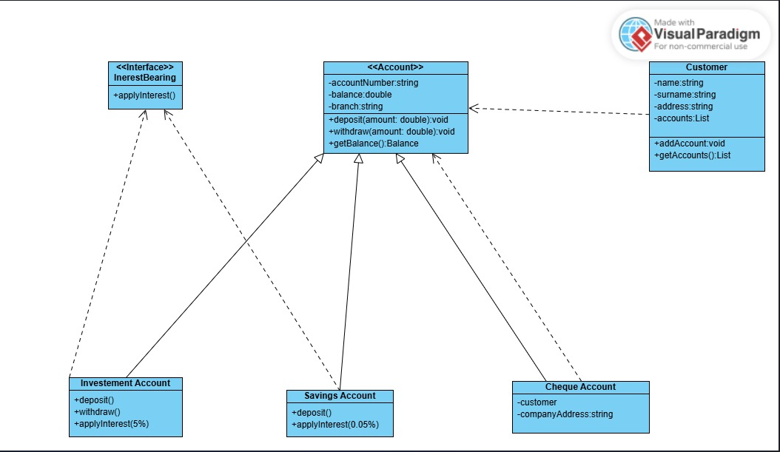

**3.Behavioural UML Modelling**

3.1. Login and Deposit Sequence Diagrams

* Login
* Deposit

3.2. State Diagram

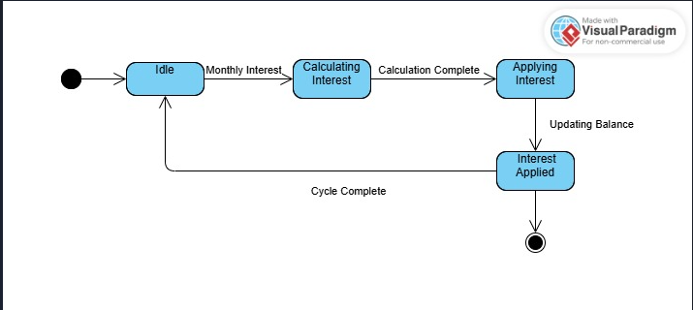

**Meeting Record Appendix**

* Objective-Requirements elicitation interview
* Date-18/09/25
* Time-10:30-12:15
* Interviewer-Ms. Tlotlo Radithamako
* Interviewee-Mr. Kentsenao Baseki

**Questions And Answers**

* Should the monthly interest require human approval, or should they be fully automated?

The monthly interest should be fully automated.

* Which currency should we use for the banking system?

You can use any currency you want for the banking system it does not matter.

* Are there any eligibility requirements for opening an account?

No, you can open an account for an individual who is younger than 16 years but there should be a guardian present.

* If a transaction fails should there be anything displayed on the screen?

Yes an alert message should be displayed on the screen if a transaction fails.

* Should the interest be applied polymorphically?

Yes because we are going to have an interface that is polymorphic.